# GRAPHIC DESIGN

**What**

is design ?

1

Use

**Figma**

2

Graphic design

**theory**

3

## Projects

6

**Analysis** of The design existing designs**workflow**

4

5

**Course evaluation**

MAR

**CHAPTER 1 -** What is design ?

**CHAPTER 2 -** Use **Figma**

APR**CHAPTER 3 -** Graphic design **theory**

**CHAPTER 4 - Analysis** of existing designs

Analysis report 30 %

**CHAPTER 5 -** The design **workflow**

MAY

**CHAPTER 6** - 3 Projects

Project 1 - 30 %

Project 3 - 40 %

FIGMA

3

**CHAPTER 2**

ENGAGE How to **work fast** on FIGMA ?

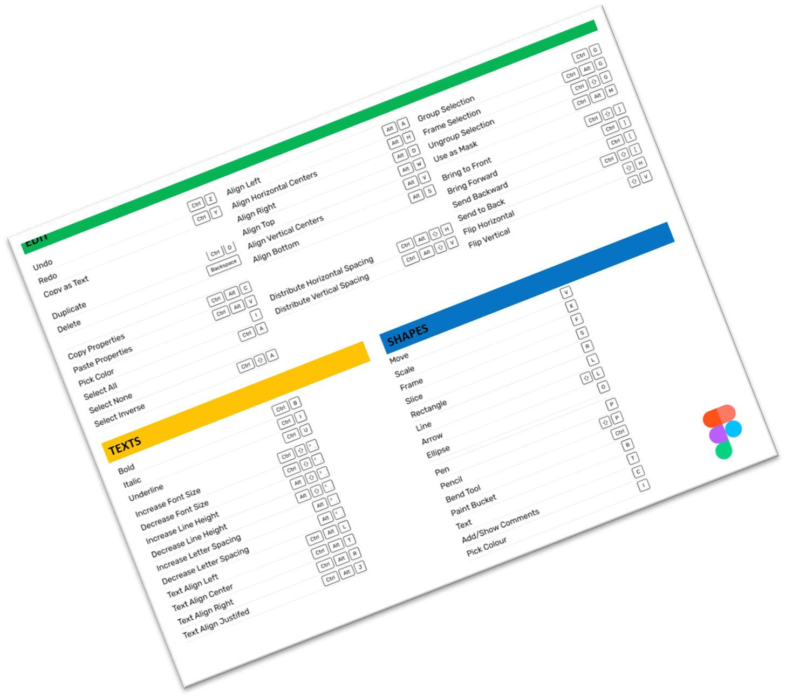

*Read the HANDOUT to learn the*

*schotcuts*



10 MIN

* use the **MOUSE** as much as possible
* use **SHORTCUTS** as much as possible

DEMO

Let's **understand**



20 MIN

* Understand trainer demo
* Read the FIGMA handout to remember each feature

Create

Select

Align

Navigate

Set

✓

Translate

✓

Frames

✓

Position

✓

Size

✓

Radius

* Zooms
* Shapes
* Pages ✓ Align
* Frames ✓ Distribute
* Shapes
* Duplicate
* Copy / Paste ✓ alignment **guides**

(red lines)

* Copy paste **properties**
* Resize with ratio
* Colors
* Color dropper
* Strokes
* Fonts

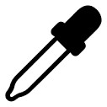PRACTICE Activity 1



20 MIN INDIV **STEP 1** Use color dropper

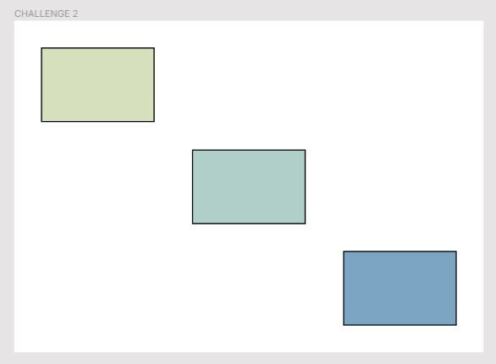

**50**

**px**

**50**

**px**

**px**

**50**

**50**

**px**

✓

Create a

**A4**

frame

✓

Orientation

**=**

**LANDSCAPE**

✓

Create the 3 rectangles as

follow

To get those colors



**px**

**130**

**200**

**px**

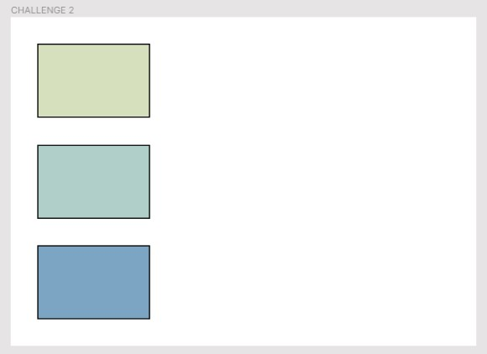

✓

Align the 3 rectangles on the

**left**

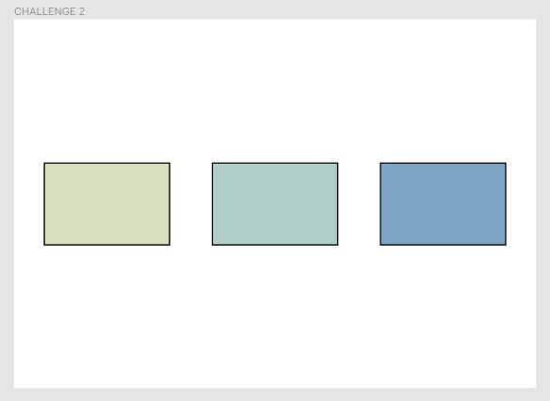

✓

Align the 3 rectangles on the

**center**

✓

Revert to step 1

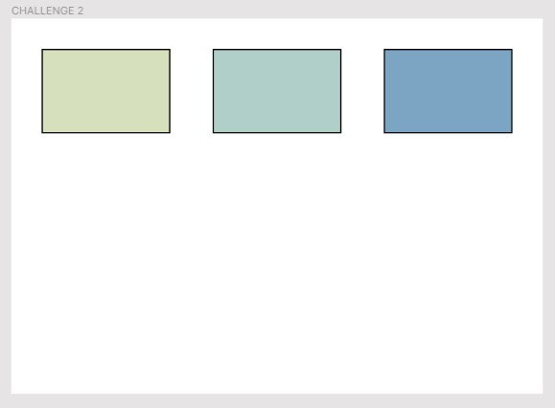

✓

Align the 3 rectangles on the

**top**

✓

Revert to step 1

20 MIN

**STEP 1**

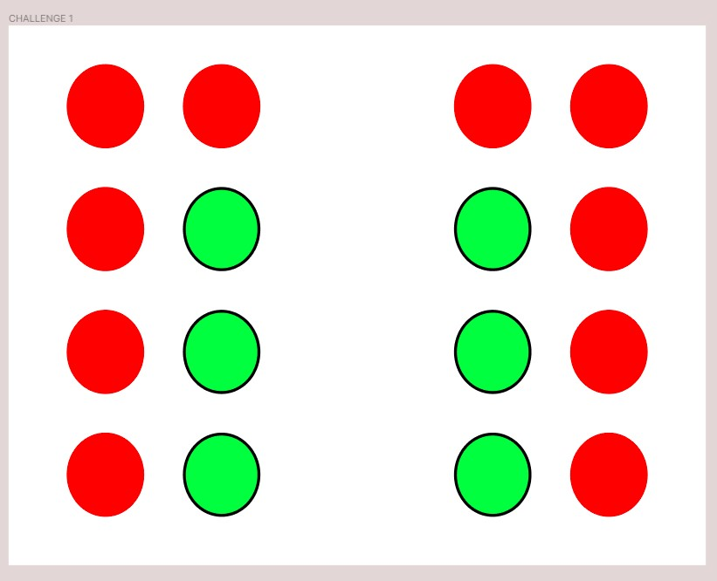

640

60

120

40

80

40

40

60

40

80

80

40

- **Think** how to do it with as less as possible operations?

**STEP 2** - Watch the **trainer demo**

520

### STEP 3

- Do it by **yourself**

20 MIN

* Get image and text from the **given power point file**
* Design this mock up using **as less as possible operations**
* 1160 x 500

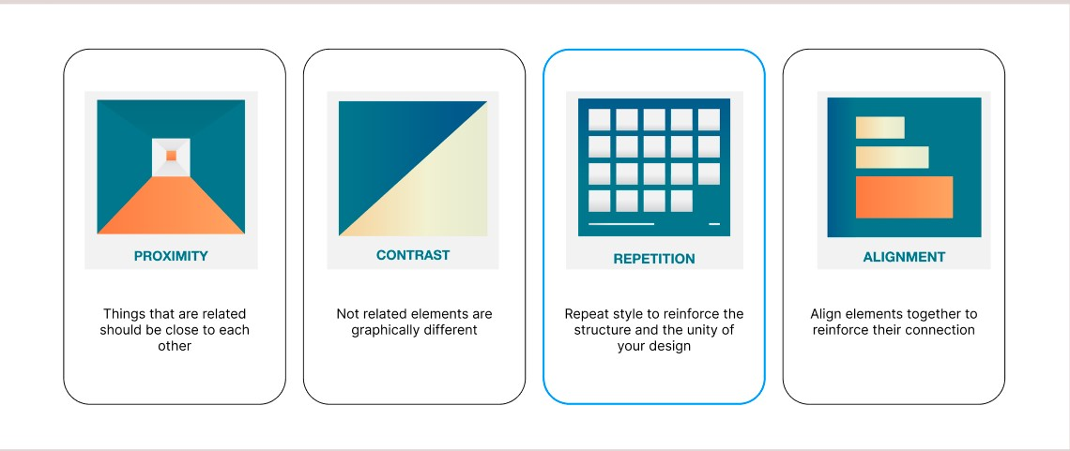

50

200

250

20

50

400

50

25

25

Font 15

30 MIN

1. – Define your grid

**600px**

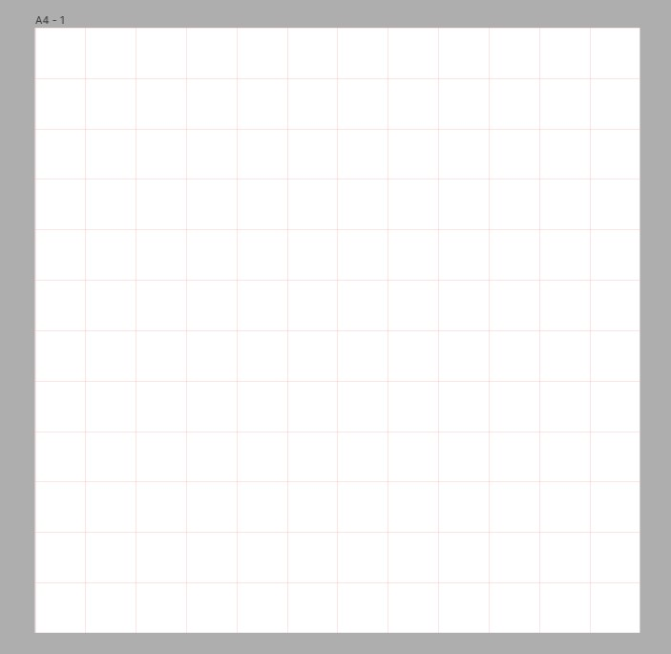

**600**

**px**

1. – Draw this image on the grid

*Find a strategy to draw* ***as fast as possible***

